Experiment No. 4

Aim: To install Kubectl and execute Kubectl commands to manage the kubernetes cluster and deploy your First Kubernetes Application (LO1, LO2)(PO1, PO2, PO3, PO4, PO5, PO8, PO9, PO10, PO12) Theory :

Kubernetes:

Kubernetes is used to create applications that are easy to manage and deploy anywhere. When available as a managed service, Kubernetes offers you a range of solutions to meet your needs. Here are some common use cases.

1. Increasing development velocity Kubernetes helps you to build cloud-native microservices-based apps. It also supports containerization of existing apps, thereby becoming the foundation of application modernization and letting you develop apps faster.
2. Deploying applications anywhere Kubernetes is built to be used anywhere, allowing you to run your applications across on-site deployments and public clouds; as well as hybrid deployments in between. So you can run your applications where you need them.
3. Running efficient services Kubernetes can automatically adjust the size of a cluster required to run a service. This enables you to automatically scale your applications, up and down, based on the demand and run them efficiently.

# Kubectl

The Kubernetes command-line tool, kubectl, allows you to run commands against Kubernetes clusters. You can use kubectl to deploy applications, inspect and manage cluster resources, and view logs. Kubectl is installable on a variety of Linux platforms, macOS and Windows.

Syntax

Use the following syntax to run kubectl commands from your terminal window:

kubectl [command] [TYPE] [NAME] [flags]

Steps to install Kubectl and execute Kubectl commands to manage the kubernetes cluster and deploy your First Kubernetes Application.

1. Install Kubernetes tools Commands:

Both Master and Slave

* 1. sudo apt-get install kubeadm kubelet kubectl –y
  2. sudo apt-mark hold kubeadm kubelet kubectl

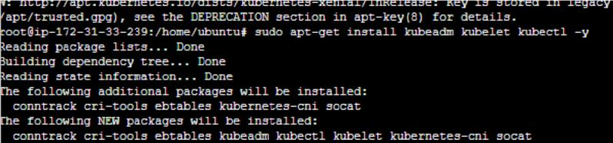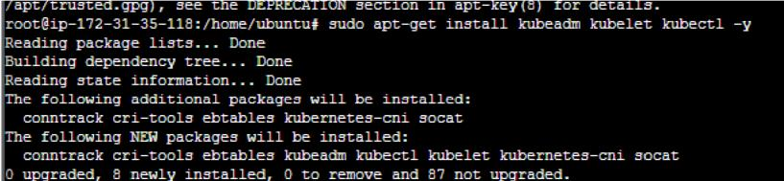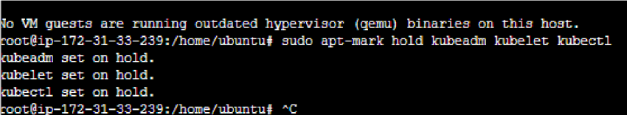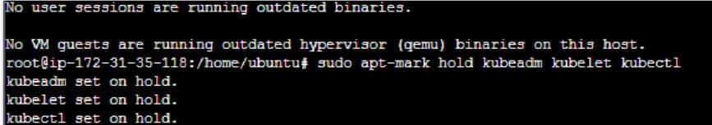

1. Verify the installation Both Master and Slave

Commands: kubeadm version

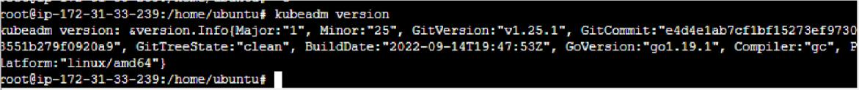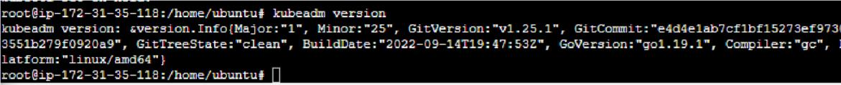

1. Begin Kubernetes deployment

Both Master and Slave

Commands: swapoff --a



1. Assign Unique Hostname for Each Server Node Decide which server to set as the master node. Next, set a worker node hostname.

On Master

Command: sudo hostnamectl set-hostname master-node

On Worker

Command: sudo hostnamectl set-hostname worker01



1. Initialize Kubernetes on Master Node On Master

Command:

* 1. sudo su
  2. sudo kubeadm init --pod-network-cidr=10.244.0.0/16

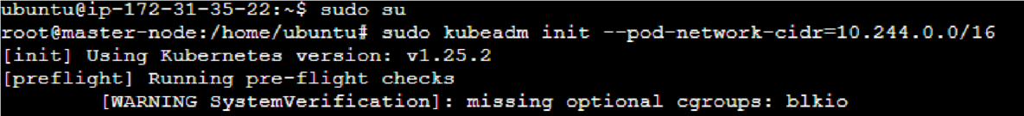

If you are trying to run this on EC2 you’ll get an error message saying less cpu and memory to override the error run the above command with --ignore-preflight-errors=all

On Master

Command: sudo kubeadm init --pod-network-cidr=10.244.0.0/16

--ignore-preflight-errors=all



Once this command finishes, it will display a kubeadm join message at the end. Make a note of the whole entry. This will be used to join the worker nodes to the cluster. Next, create a directory for the cluster.

On Master

Command:

* 1. mkdir -p $HOME/.kube
  2. sudo cp -i /etc/kubernetes/admin.conf $HOME/.kube/config
  3. sudo chown $(id -u):$(id -g) $HOME/.kube/config



1. Deploy Pod Network to Cluster. On Master

Command:sudo kubectl apply-f https://raw.githubusercontent.com/coreos/flannel/master/Documentation/kube-flannel.y ml



Allow the process to complete.

Verify that everything is running and communicating.

On Master

Command: kubectl get pods --all-namespaces

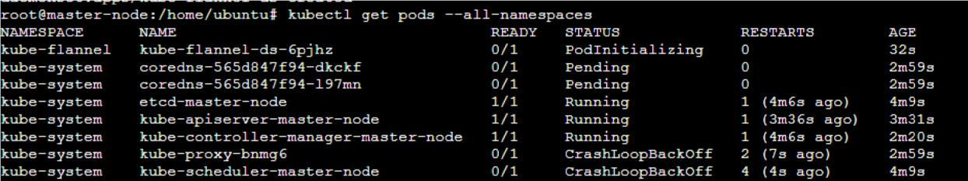

1. Join Worker Node to Cluster. you can enter the kubeadm join command on each worker node to connect it to the cluster. Switch to the worker01 system. On Worker Command:
   1. sudo su
   2. kubeadm join 172.31.44.201:6443 --token iv4qnb.7aczfwllmfs4o7sc

--discovery-token-ca-cert-hash sha256:33faf5ca90d079f20f6d1d48ca1bd225bc858462dbe0881418e7eeae4c4db075

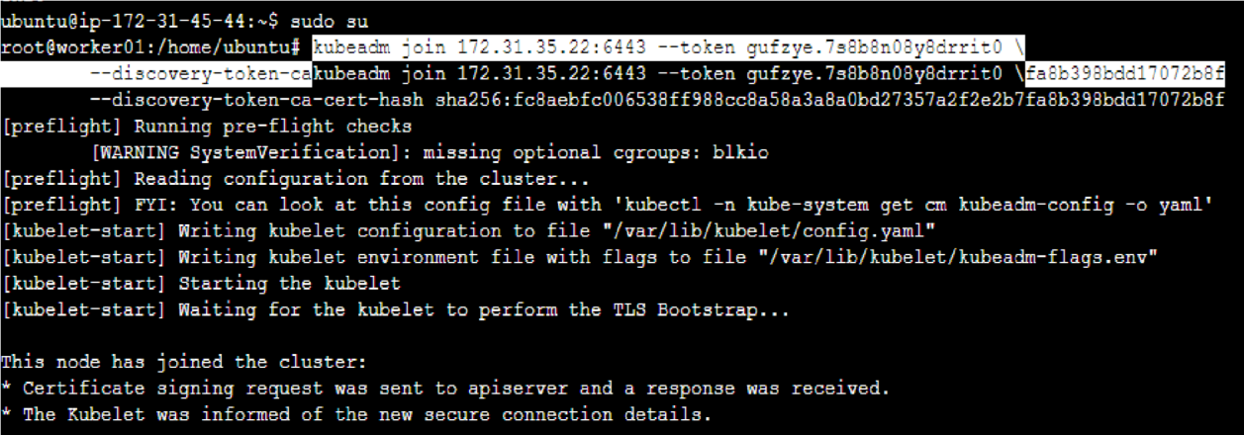

Switch to Master server.

The system should display the worker nodes that you joined to the cluster.

On Master.

Command: kubectl get nodes

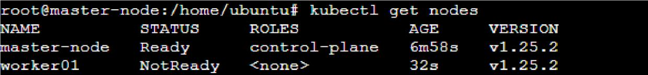

1. Running An Application on the Cluster. Deploy any containerized application to your cluster.

On Master.

Command: kubectl create deployment nginx –image=nginx



1. Create a service named nginx that will expose the app publicly. On Master.

Command: kubectl expose deploy nginx --port 80 --target-port 80 --type NodePort



10.Services are another type of Kubernetes object that expose cluster internal services to clients, both internal and external.

On Master.

Command: kubectl get services

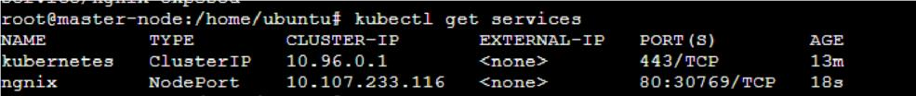

From the output you can retrieve the port that Nginx is running on. To test that everything is working, visit http://worker_1_ip:nginx_port

11. Check the deployed container on the worker node.

On Worker.

Command: docker ps

12.To scale up the replicas for a deployment (nginx in our case) On Master. Command:

1. kubectl scale --current-replicas=1 --replicas=2
2. kubectl get pods
3. kubectl describe deployment/nginx

13.Remove the Nginx application. So first delete the nginx service from the master node. Then check that the service has been deleted.

On Master. Command:

1. kubectl delete service nginx
2. kubectl get services

14.Delete the deployment. Then check if it has been deleted.

On Master. Command:

1. kubectl delete deployment nginx
2. kubectl get deployments

15.Delete the node by Finding it, Draining it and then finally deleting it.

On Master. Command:

1. kubectl get nodes
2. kubectl drain nodetoberemoved
3. kubectl delete node nodetoberemoved

16.Remove join/init setting from Worker node On Worker.

Command:

1. kubeadm reset
2. docker ps On Master. Command: kubectl get nodes Conclusion :

From this experiment, we have studied about the Kubernetes Cloud. We have understood how to install Kubectl and execute Kubectl commands to manage the Kubernetes cluster and deploy Your First Kubernetes Application. We have achieved LO1 and LO2 from this experiment. We have achieved PO1, PO2, PO3, PO4, PO5, PO8, PO9, PO10 and PO12 from this experiment.